HW Assignment 3
Name: Eldana Hailemichael
Concept (show your answer in calculation)
- Suppose we collect data for a group of students in a statistics class with variables X1 =hours studied, X2 =undergrad GPA, and Y = receive an A. We fit a logistic regression and produce estimated coefficient, ${\hat{β}}_{0}$= −6, ${\hat{β}}_{1}$= 0.05, ${\hat{β}}_{2}$= 1.
- Estimate the probability that a student who studies for 40 h and has an undergrad GPA of 3.5 gets an A in the class.
(a)
Given:
β₀ = -6
β₁ = 0.05
β₂ = 1
X₁ = 40 (hours studied)
X₂ = 3.5 (GPA)
Step 1: Compute the linear predictor
logit(p) = β₀ + β₁X₁ + β₂X₂
logit(p) = -6 + 0.05(40) + 1(3.5)
logit(p) = -6 + 2 + 3.5
logit(p) = -0.5
Step 2: Convert logit to probability
p = e^(logit(p)) / (1 + e^(logit(p)))
p = e^(-0.5) / (1 + e^(-0.5))
p = 0.6065 / 1.6065
p = 0.3775
Estimated probability: p = 0.3775 (about 37.75%)

b. We want p = 0.5.
At p = 0.5, logit(p) = 0.
0 = β₀ + β₁X₁ + β₂X₂
Solve for X₁:
X₁ = - (β₀ + β₂X₂) / β₁
Substitute the values:
X₁ = - (-6 + 1(3.5)) / 0.05
X₁ = - (-2.5) / 0.05
X₁ = 2.5 / 0.05
X₁ = 50
Required study hours: X₁ = 50 hours

R application (Please include your answer and R/R studio code and output (copy paste your code and screenshot your R output for each sub-question where R is used).
- This question should be answered using the Weekly data set, which is part of the ISLR package.
To obtain the Weekly data, Run:
library(ISLR)
data(Weekly)
- Plot weekly volumes over time. Do there appear to be any patterns? Yes, trading volume generally increases through the 1990s/2000s.
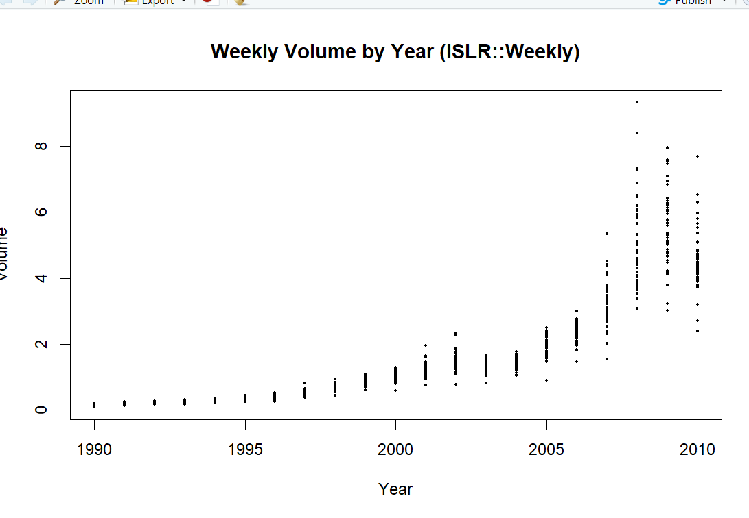
Code: # (a) Plot weekly volumes over time
png(filename = "weekly_volume.png", width=900, height=400) # save as PNG
plot(Weekly$Year + (as.numeric(rownames(Weekly)) / nrow(Weekly)), Weekly$Volume,
type="l", xlab="Index (time)", ylab="Volume",
main="Weekly Volume over time (ISLR::Weekly)",
lwd=1)
# Better time axis using Year: jittered per row index for visual separation
plot(Weekly$Year, Weekly$Volume, type="p", pch=20, cex=0.6,
xlab="Year", ylab="Volume", main="Weekly Volume by Year (ISLR::Weekly)")
dev.off()

# Also show inline
plot(Weekly$Year, Weekly$Volume, type="p", pch=20, cex=0.6,
xlab="Year", ylab="Volume", main="Weekly Volume by Year (ISLR::Weekly)")
(b) Use the full data set to perform a logistic regression with Direction as the response and the five lag variables plus Volume as predictors. Use the summary function to print the results. Do any of the predictors appear to be statistically significant? If so, which ones? Code: # (b) Full-data logistic regression
fit_full <- glm(Direction ~ Lag1 + Lag2 + Lag3 + Lag4 + Lag5 + Volume,
data = Weekly, family = binomial)

# Save the summary output to file for screenshot
sink("logistic_full_summary.txt")
print(summary(fit_full))
sink()

# Print to console as well
summary(fit_full)
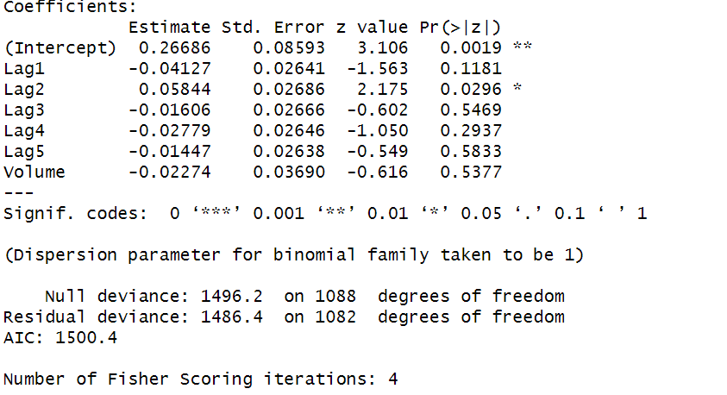

(c) Compute the confusion matrix and overall fraction of correct predictions. Explain what the confusion matrix is telling you about the types of mistakes made by logistic regression. Code: # (c) Predictions on the full dataset
probs_full <- predict(fit_full, type = "response")
preds_full <- ifelse(probs_full > 0.5, "Up", "Down")
preds_full <- factor(preds_full, levels = c("Down", "Up"))

# Confusion matrix and overall accuracy
cm_full <- table(Predicted = preds_full, Actual = Weekly$Direction)
acc_full <- mean(preds_full == Weekly$Direction)

# Save outputs
sink("logistic_full_confusion.txt")
print(cm_full)
cat("Overall accuracy:", acc_full, "\n")
sink()

# Show in console
cm_full
acc_full
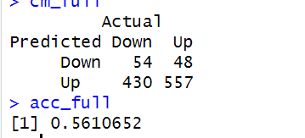

The confusion matrix shows that the model correctly predicts 557 “Up” weeks and 54 “Down” weeks, giving an overall accuracy of about 56%, but it frequently misclassifies “Down” weeks, indicating the model is biased toward predicting “Up.
(d) Now fit the logistic regression model using a training data period from 1990 to 2008, with Lag2 as the only predictor. Compute the confusion matrix and the overall fraction of correct predictions for the test data (that is, the data from 2009 and 2010).
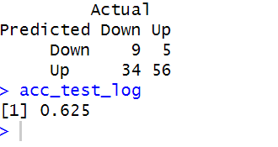

Code: # (d) Train/test split using Year
train <- Weekly$Year <= 2008
test <- Weekly$Year >= 2009

# Fit logistic on training set with Lag2 only
fit_train_lag2 <- glm(Direction ~ Lag2, data = Weekly, family = binomial, subset = train)

# Summary (save)
sink("logistic_train_lag2_summary.txt")
print(summary(fit_train_lag2))
sink()
summary(fit_train_lag2)

# Predictions on test set
probs_test_log <- predict(fit_train_lag2, newdata = Weekly[test,], type = "response")
preds_test_log <- factor(ifelse(probs_test_log > 0.5, "Up", "Down"), levels = c("Down","Up"))

cm_test_log <- table(Predicted = preds_test_log, Actual = Weekly$Direction[test])
acc_test_log <- mean(preds_test_log == Weekly$Direction[test])

# Save confusion & accuracy
sink("logistic_test_lag2_confusion.txt")
print(cm_test_log)
cat("Overall accuracy (test):", acc_test_log, "\n")
sink()

# Show in console
cm_test_log
acc_test_log
(e) Repeat (d) using LDA.
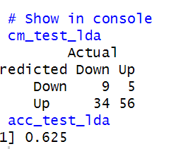
Code: # (e) LDA with Lag2
lda_fit <- lda(Direction ~ Lag2, data = Weekly, subset = train)
# Save summary-ish output
sink("lda_fit_summary.txt")
print(lda_fit)
sink()
lda_fit

# Predict on test set
lda_pred <- predict(lda_fit, newdata = Weekly[test,])
preds_lda <- factor(lda_pred$class, levels = c("Down","Up"))

cm_test_lda <- table(Predicted = preds_lda, Actual = Weekly$Direction[test])
acc_test_lda <- mean(preds_lda == Weekly$Direction[test])

# Save confusion & accuracy
sink("lda_test_confusion.txt")
print(cm_test_lda)
cat("Overall accuracy (test, LDA):", acc_test_lda, "\n")
sink()

# Show in console
cm_test_lda
acc_test_lda
(f) Repeat (d) using QDA.
Code: # (f) QDA with Lag2
qda_fit <- qda(Direction ~ Lag2, data = Weekly, subset = train)
# Save
sink("qda_fit_summary.txt")
print(qda_fit)
sink()
qda_fit

# Predict on test set
qda_pred <- predict(qda_fit, newdata = Weekly[test,])
preds_qda <- factor(qda_pred$class, levels = c("Down","Up"))

cm_test_qda <- table(Predicted = preds_qda, Actual = Weekly$Direction[test])
acc_test_qda <- mean(preds_qda == Weekly$Direction[test])

sink("qda_test_confusion.txt")
print(cm_test_qda)
cat("Overall accuracy (test, QDA):", acc_test_qda, "\n")
sink()

# Show in console
cm_test_qda
acc_test_qda
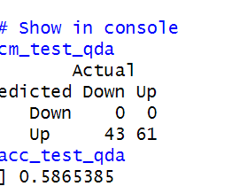

(g) Repeat (d) using KNN with K = 1.
Code: # (g) KNN with K = 1 using Lag2
# Prepare data (matrix form) and scale training values
train_X <- as.matrix(Weekly$Lag2[train])
test_X <- as.matrix(Weekly$Lag2[test])

# It's good practice to standardize (though with single predictor it's optional)
means <- mean(train_X)
sds <- sd(train_X)
train_Xs <- scale(train_X, center = means, scale = sds)
test_Xs <- scale(test_X, center = means, scale = sds)

train_labels <- Weekly$Direction[train]
# Run KNN, k = 1
set.seed(1)
knn_pred <- knn(train = train_Xs, test = test_Xs, cl = train_labels, k = 1)

preds_knn <- factor(knn_pred, levels = c("Down","Up"))
cm_test_knn <- table(Predicted = preds_knn, Actual = Weekly$Direction[test])
acc_test_knn <- mean(preds_knn == Weekly$Direction[test])

sink("knn_test_confusion.txt")
print(cm_test_knn)
cat("Overall accuracy (test, KNN k=1):", acc_test_knn, "\n")
sink()

# Show in console
cm_test_knn
acc_test_knn
(h) Which of these methods appears to provide the best results on this data?
Code: results <- data.frame(
Method = c("Logistic (Lag2)", "LDA (Lag2)", "QDA (Lag2)", "KNN k=1 (Lag2)"),
Accuracy = c(acc_test_log, acc_test_lda, acc_test_qda, acc_test_knn)
)
print(results)
sink("method_comparison.txt")
print(results)
sink()
results
